**Vintage-Revival**

|  |  |  |  |  |  |  |  |
| --- | --- | --- | --- | --- | --- | --- | --- |
| **Vintage Revival Montlhery 2019 – 11 & 12 May** |  | | |  |  |  |  |
|  |  |  |  |  |  |  |  |
| Dear Participant, | |  |  |  |  |  |  |
|  |  |  |  |  |  |  |  |
| Please find below your subscription form as a track sessions participant for Board Track Racer motorcycle & exception to the  Vintage Revival Montlhery 2019. | | | | | | | |
|  | | | |  |  |  |  |
| Please fill and return the completed registration form (page 2) and the signed Briefing, rules and regulations(page 4). |  |  |  |  |  |  |  |
|  | | Copie des deux documents ci-dessous. | | | | |  |
| Please arrange your payment transfer in full within the following 4 weeks. See the payment details in Article 1 of the regulations.  On receipt of your payment, you will be sent your official participation number which must be shown to the staff on arrival at  the circuit. |  |  | | | | | |
| Do not hesitate to contact us for any information you may require. |  |  |  |  |  |  |  |
|  |  |  | |  |  |  |  |
| *Kind regards* |  |  |  |  |  |  |  |
| We would be most grateful if you could advise us as soon as possible should you have to cancel for any reason. |  |  | |  |  |  |  |
| VRM Organisation |  |  |  |  |  |  |  |
|  |  |  |  |  |  |  |  |
|  | | | | |  |  |  |
|  |  |  |  |  |  |  |  |
| Nouveau LOGO vrm 2013 | |  |  |  |  |  |  |
|  |  |  |  |  |  |  |  |

**France :**Association Vintage Revival  
28, Rue de la rotonde  
58000 NEVERS

Web : http://www.vintage-revival.fr/  
Président : Vincent Chamon - vintage-revival-montlhery@outlook.com  
Téléphone : 06 59 50 39 13  
Fax : 03 86 21 44 65

**Angleterre – UK Representant :**Jean-Frédéric Frot -jffrot@btconnect.com  
Tél : 0044 1254 824590  
Port : 0044 7746 776696

**Hollande – NL Representant :**Kees – VRM.NL@outlook.com

**Allemagne – De Representant :**Frank Seeger - [fs@anzani.de](mailto:fs@anzani.de)Tél : 0049 74312280Port : 0049 1727605798 

**N°**

**Vintage-Revival**

www.vintage-revival.fr

**REGISTRATION FORM**

**(Circuit access)**

**Pré 1919 & Exception**

**Track**

**Participant**

Track of Linas-Montlhéry

11 & 12 May 2019

Nom / Surname : Prénom / First name :

Tél : e-mail :

Véhicule / Vehicle:

Moto / Motorcycle :

( Motocyclette Board Track Racer et Exception. )

( Board Tarck Racer Motorcycle & Exception)

Marque / Make:

Model: Carrosserie / Body :

Année du véhicule / Year: Cylindrée / Capacity  cm3/cc

Estimatif vitesse du véhicule:

(Estimated speed of vehicle )

Remorque de plus de 3 mètres de haut / Trailer of more than 3 meters in height : Oui/Yes  Non/No X

**Insérez une Photo du Véhicule / Insert one Picture of the Vehicle**

**Final date   
for entries**

**March 1st  
 2019**

**Clôture des**

**inscriptions**

**1er Mars  
 2019**

## Pas de validation de l’engagement si le règlement n’est pas signé / daté The regulations must also be signed and dated or the entry will not be accepted

**Barbecue, Alcool sont interdits dans l’enceinte du circuit  
Barbecues, alcohol are forbidden  
  
Inscriptions : uniquement véhicules pré 1940 ou exception ( nous consulter )  
 A Retourner à : Vintage Revival / 28, Rue de la rotonde 58000 Nevers  
( Voir Article 1 du REGLEMENT )**

[www.vintage-revival.fr](http://www.vintage-revival.fr)

|  |  |
| --- | --- |
| REGULATIONS  **Article 1 – Participation**  **If you wish to participate you must return the following to :**  **Association Vintage Revival, 28 Rue de la Rotonde, 58000 Nevers,**  **before March 1st 2019 :**   * These regulations: read, completed and signed. * The entry form: completed and signed with a picture of the vehicle. * Payment : -- **by direct transfer** to our bank account at Banque Populaire de Bourgogne, Nevers, France . IBAN number : FR76 1080 7004 4972 2216 9503 372. SWIFT/BIC Code: CCBPFRPPDJN ). Account Name Association Vintage Revival. **Important** : Please give your surname as the reference for the bank transfer and **specify to your bank that all costs and commissions are to your account.** - **by Paypal** to our e-mail address:   vintage-revival-montlhery@outlook.com and quoting your surname and entry number in the message box**. Please add €10.00 to your total to cover the commissions**  If a participant’s cancellation is received by 1 February 2019, he/she will receive full reimbursement less an administration fee of €10. If notice is received between 1st February and 1st March 2019, 50% reimbursement will be repaid, less the €10 admin fee. After 2nd March 2019 no reimbursement will be made.  The Vintage Revival committee reserves the right to decline any registration request without justification and no appeal will be considered.    If bad weather prevents the event taking place whether in whole or in part, or if circumstances require the organisers or site owners to close the circuit during the event, no reimbursement will be made.    If the site owner gives advance notice that the event cannot take place, the organisers will make their best efforts to reimburse.  There will be no refund in the event of exclusion for not observing these regulations.  Article 2 – Parking  Two parking areas will be reserved for participants.   * Parking of modern vehicles * Parking of pre-1940 vehicles and other acceptable vehicles (see Article 8)   **Article 3 – Participant Timetable**  Friday: **13.30 to 17.30**. Strictly drop-off of trailer and/or car, please do not stay at the circuit longer than necessary.  Saturday: Circuit opens **7.30 till 18.25**.  Sunday: Circuit opens **8.00 till 18.25**.  **Article 4 – Circuit and Paddock**  Only participating vehicles are allowed access to the circuit, the paddock and the pits. These areas are strictly forbidden to persons on foot. You must remain within the authorized zones at all times Article 5 – Appropriate behaviour on the site  Montlhéry is a private industrial site.  The use of any motor vehicle on the site is to be kept to a minimum and must be at low speed.  Please make use of the toilets and waste bins provided and leave the area clean  For safety reasons and in order to avoid pollution the following are forbidden on the site:   * Camping * Barbecues * Pets * Drones   Decent clothing is expected.  The organisers reserve the right to expel anyone whose behaviour has  been judged dangerous and/or does not comply with these regulations  **Article 6 – Meals**  Lunches will be available on site from the site owners (to be booked on the entry form). There will also be a snack bar.    Article 7 - Accommodation  A list of nearby hotels and campsites is available on our web site http://www.vintage-revival.fr  Camping is forbidden at the circuit. Nobody will be allowed to remain on the premises, which will be locked and guarded outside the opening times.  Camping will be available at :  1*) "Le Beau Village ", 15 Min from Autodrome, if reserved in advance (see separate information and price list ). Information: [www.beau-village.com](http://www.beau-village.com) .  2*) "Fontenay les Bris ", 10-15 Min from Autodrome, if reserved in advance (see separate information and price list ).  Information-reservation – email direct : font.briis@orange.fr  Please book this in advance on the campsite form..  **Article 8 – Acceptable vehicles**  **On the circuit:**   * Any vehicle of sporting character built prior to 1940. * Post 1940 vehicles, or not of sporting character, subject to individual authorisation.   Each vehicle will be scrutineered before it is permitted onto the circuit. This scrutineering does not imply any warranty by the organisers as to the state of the vehicle  **For display:**   * Any vehicle built prior to 1940. * Post 1940 vehicles, subject to individual authorisation.   Display vehicles will be admitted on to the circuit only for the final parade  Vintage Revival has the right to reject any vehicle without justification or appeal will be considered.      Vintage Revival Montlhery | Article 9 – Circuit groups  In order to ensure safety during each session, separate groups will be formed according to age, power, type and theme. Each participant must stay within his/her group or will be expelled from the circuit.  **Article 10 – Access to Circuit and Paddock**  A paddock will be available for those participants with access to the circuit.  The participants must comply with the rules governing paddock parking and access to the circuit. All movements must be at low speed.  A parking area adjoining the paddock will be available for support vehicles, trailers etc.  Only vehicles displaying a sticker with the colour of the relevant group will be admitted to the pre-start position. Vehicles must be at the pre-start position 15 minutes before the start of their group. A schedule will be available at the time.  **Article 11 – Driver and Passengers**  Every driver and passenger going onto the circuit area does so at their own risk and the driver must sign the Declaration below.  Except for specified groups   * Only one passenger will be allowed. * ***The driver and passenger must wear an approved crash helmet, or will be denied access to the circuit.***   To maintain the vintage style participants are encouraged to wear overalls or a jacket and long trousers.  The clerk of the course has the right to enforce breath tests. In case of refusal, access to the circuit will be denied.  **Article 12 – Observance of circuit regulations.**   * Each participant must attend a briefing by the clerk of the course. * Any behaviour deemed dangerous or unsporting will result in expulsion from the group. A black flag will be shown. * On the banked corners a maximum of two cars side by side is allowed. * Participants must cover their headlights with adhesive tape. * The car must not carry any loose and unnecessary objects. * All vehicles must be equipped with silencers. Noise levels are liable to be checked and must not exceed 95 dba.   Repeated breach of these regulations may lead to the complete stop of a group.  **Article 13 – Insurance**  All land motor vehicles must have an up-to-date liability insurance covering physical and material damage during the event.  Each driver agrees to take out an insurance policy from a reputable company covering risks he or she may encounter during this event.  You can consult the VRM Insurance for all questions and to subscribe an individual supplementary insurance (this applies to passengers also) .  The exhibited vehicle must be insured for physical injuries to any person and for damages to any other véhicule or structure. .  ***DECLARATION***  I sign below and confirm that I have subscribed to a personal accident insurance policy for this event.**Further I understand that all persons having any connection with the promotion and/or organisation and/or conduct of the event are insured against loss or injury caused through their negligence.**  I have read and understood these regulations and in particular the safety instructions. By my signature I accept responsibility for the consequences of my acts or omissions. At_____________________ ______________________(place)the __________________________________________ (date) Insert here “Lu et approuvé” (“seen and agreed”)  ____________________________  (signature)  ________________________________  (forename & surname)  If you return this regulation by e-mail, please insert your name capital letters in the “signature” box .  NOTE: This translation is provided only for the convenience of participants. In case of dispute the original French text will prevail. |

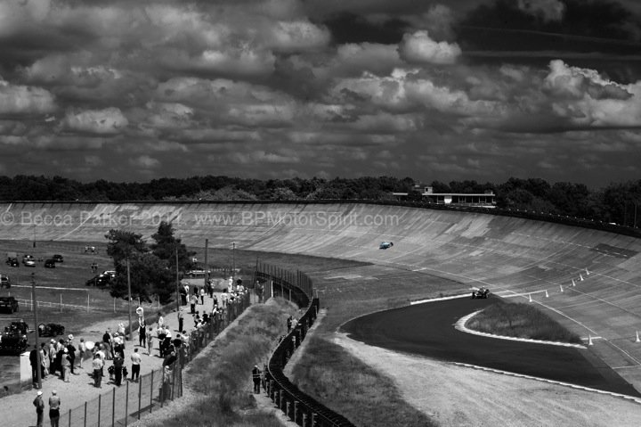

VRM 2011 By Becca Parker © "Tous droits réservés" : http://www.bpmotorspirit.com/



N°

|  |
| --- |
|  |

**MAIN TRACK BRIEFING**

*Hello & welcome to the Autodrome de Linas-Montlhéry!*

*You are about to drive on the 3.405 kms track which is part of the history of motorsport.*

*We would like to kindly remind you of a few safety rules which will allow everyone to enjoy and share their passion with other car enthusiasts in a responsible manner.*

*The track is managed by the UTAC team, with marshals and a safety unit. So, for safety reasons, we ask you to observe the instructions given below.*

**OUTSIDE OF THE TRACK**

You are on a confidential private site, so we ask you to stay in the dedicated areas of the event determined by the organisers.

We ask you to respect the basic rules when driving anywhere on the site (low speed, respect walkers, noise, etc…)

**INSIDE THE TRACK**

It is strictly forbidden to stop your car on the track.

It is strictly forbidden to walk on the track.

In case of emergency, the driver should do all in his power to park his car in a safe area, as far as possible from the track.

The drivers must observe the instructions given by the mean of flags shown by the marshals on the side of the track.

Any damages caused by a driver to the circuit will be charged and paid for by said driver immediately at the track.

It is strictly forbidden to smoke whilst driving on the track.

It is forbidden to use your mobile phone whilst on the track

Slick tyres are forbidden

No loose objects in the cockpit.

Video cameras must be secured to the bodywork by a metal cable or a strong tie-wrap.

Helmets should meet the latest EN standards

You are using the track in a leisure context and the maximum speed is limited to 150km/h (95mph)

Strictly observe the instructions given by the UTAC team and its marshals:

**Blue flag** = You are about to be overtaken by a faster vehicle. Do not change track position.

Please try and signal to the vehicle which is about to overtake you to acknowledge that you are aware

of its presence (hand signal or indicators)

**Red flag** = stop of the driving session before the expected time. Return to the paddock immediately and carefully

at a reduced speed

**Yellow flag** = slow right down, danger ahead. Overtaking strictly forbidden. Be prepared to stop if necessary.

**Black flag** = the driver to whom the flag is shown must to come back to the paddock immediately and at a reduced speed.

This flag means that your behaviour is dangerous to other drivers and the public or that your car has developed a

fault that is dangerous to you or the other drivers, loss of oil for instance.

The director of the track is opening and closing the track, by doing one lap to check the state of the track and that the marshals are in position.

Each session (group of vehicles) is starting by doing **2 laps** slowly **behind a pace-car**, **no overtaking during these laps**. Once the flashing lights of the pace car are off, the session proper starts and overtaking is allowed (including the pace car which might stay on the track for further laps)

Each session is ending by **a slow-down lap** mentioned by the signpost held by a marshal.

It is strictly **forbidden to overtake at the chicanes at any time**.

**PIT LANE**

You can drive only in one way.

The speed limit in the pit lane is **30km/h (20mph) at all times**.

The access to the pit-lane is forbidden to children even accompanied by an adult.

It is strictly forbidden to smoke in the pit-lane.

The pit lane is divided in three areas by cones:

**The Walking area** is strictly for the organisers.

**The right lane** is for the assembly of cars for the next session (grid)

**The left lane** is for exiting the track at the end of the pit-lane by the ramp behind the “Espace Total”).



**Blue flag**

A car is about to overtake you. Do not change direction, stay on the same side of the track until you have been overtaken.

Please try and signal to the vehicle which is about to overtake you to acknowledge that you are aware of its presence .

(hand signal or indicators)

**Red flag**

Stop of the driving session before the expected time. Return to the paddock immediately and carefully at a reduced speed

**Black flag**

The driver to whom the flag is shown must to come back to the paddock immediately and at a reduced speed. This flag means that your behaviour is dangerous to other drivers and the public or that your car has developed a fault that is dangerous to you or the other drivers, loss of oil for instance.

**Yellow flag**

Held still: Slow right down, danger ahead. Overtaking strictly forbidden. Be prepared to stop if necessary. There is a danger on the side of the track.

Waved: Slow down and do not overtake, there is a danger on the track, be prepare to change direction to avoid obstructions.

Two flags waved: Slow down and do not overtake, the track is partially or totally obstructed, be prepared to stop if necessary.

Only resume normal driving once you have passed a green flag

***DECLARATION***

*I, the undersigned, confirm that I have subscribed to an insurance policy covering personal injuries for this event.*

*I understand that all the individuals in any relation with the promotion, the organisation and the running of the event have subscribed to an insurance policy covering damages to objects and/or personal injuries occurred as a result of their negligence.*

I have read and understood the above regulations and in particular the safety instructions. By signing this document I take full responsibility for the consequences of my actions and omissions.

**……………………… le ……………………………………**

**Please hand write "Lu et approuvé" (read and approved) and sign**

Driver n°1

Driver n° 2

Et / And

**Si vous retourner le présent règlement Briefing par e-mail, merci d’indiquer la mention « lu et approuvé » avec votre nom dans la case au-dessus.**

**Event et Formation**

**PARIS AUTO EVENTS**

**Autodrome de Linas-Montlhéry – BP 20212**

**91311 Montlhéry Cedex - FRANCE**

**TARIFS / CHARGES**

#### Tarifs Week-end PISTE - Charges for the weekend (Vintage car Track-access) :

***Tarif unique Motocyclettes Board Track Racer ou exception :***

***Charge for one Board Track Racer Motorcycle & Exception :***

* 1véhicule – 2 personnes / One vehicle and two people : = = €

* 1 véhicule – 2 personnes et une plaque souvenir VRM 2019 : 1 Plaque = 7 € = €

*One vehicle and two people and 1 Commemorative Rally plaque VRM 2019*

* Assurance Individuel Accident du 11 au 12 Mai 2019 : 1 Pers = 20 € = €  
   ( Individual accident insurance / period 11 to 12 May 2019 )

*-------------------------------------------------------------------------------------------------------------------------------------****Tarif accompagnateur / Charge for each additional person  :***

* 1 Jour 1Pers – One Day : 10 € x _____ = €

* 2 Jours 1Pers – Week-end : 15 € x = €

( Gratuit pour les moins de 16 ans / No charge for persons under 16 )

**-------------------------------------------------------------------------------------------------------------------------------------**

***Restauration au circuit / Lunch at the Track :***

**Samedi Midi / Saturday**

* LOMBARD : x 18,00€ = €

* ASCARI : x 23,00€ = €

**Dimanche Midi / Sunday noon**

* LOMBARD : x 18,00€ = €

* ASCARI : x 23,00€ = €

**REPAS VEGETARIEN POSSIBLE ( Nous consulter :** [vintage-revival-montlhery@outlook.com](mailto:vintage-revival-montlhery@outlook.com) **)**

***VEGETARIAN LUNCH POSSIBLE ( Please contact :*** [vintage-revival-montlhery@outlook.com](mailto:vintage-revival-montlhery@outlook.com) ***)***

Voir feuille suivante pour le descriptif des menus

-------------------------------------------------------------------------------------------------------------------------------------

Retour des inscriptions

(Voir Article 1 – Inscription sur le REGLEMENT)

Association Vintage Revival

28, Rue de la rotonde

58000 Nevers

www.vintage-revival.fr

**Free**

**free**

**Total** €

 **RESTAURATION** 

Vintage Revival & « Brault Traiteur » chopice of meals for Saturday & Sunday lunches:

Bookings ensure that you do not queue during the event!

A roofed spacewith tables and chairs will be available for people who have booked hot meals

**SATURDAY LUNCH**

**Lombard Menu**18,00 Euros inc

( Cold Take away meal per person )

* Ballotin of Semi Smoked Salmon, Young Leeks with Fennel cream * Roast Beef – Tomatoes Mozarella & Basil

* Brie cheese– Green salad

* Vanilla Russian Biscuit and Custard

* Bottled Mineral Water 50 c

**Ascari Menu**

23,00 Euros Prix TTC

( Hot Meal at the Cantine per person )

* Ballotin of Semi Smoked Salmon, Young Leeks with Fennel cream

* Parmentier of Duck, with vegetables in Provençale sauce

* Brie cheese – Green salad

* Vanilla Russian Biscuit and Custard

* Choice of mineral water or cola or coffee )

**SUNDAY LUNCH**

**Lombard Menu**18,00 Euros inc

( Cold Take away meal per person )

*Home-made Whiting and Scallop Mousse – cocktail sauce * Roasted Filets of Duck- Ratatouille –Green bean salad with parmesan

* Pont Lévêque cheese – Green salad

* Apricot Pie and Almonds

* 1 non alcoholic drink

**Ascari Menu**

23,00 Euros Prix TTC

( Hot Meal at the Cantine per person )

* Home-made Whiting and Scallop Mousse – cocktail sauce

*Guinea Fowl Gicolette in Cider & Apples – vegetable gratin

* Pont Lévêque Cheese – Green salad

* Apricot Pie and Almonds

* Mineral Water, Cola or Coffee

***Végétarian meals can be ordered on special request 1 month in advance***

**\* ) Snack-Buvette *“Vintage” :***

( Sandwiches, Salads, Hot Dogs, Burgers and hot and cold drinks in P1 et P7 areas)

[*www.vintage-revival.fr*](http://www.vintage-revival.fr)

PLANNING 2019

***FRIDAY 10/05/2019 – VEHICLES AND TRAILERS DROP ONLY-***

* 09:00 : Open for traders, bring and buy and spares installation only.
* 13:30 : Open to all participants to drop vehicles and trailers.

*Limited time available, please do not stay longer than necessary*

* 17:30 : Access closed to all non-UTAC personnel

**(Entrance access to the circuit closed - 17:00 - 17:05 )**

***SATURDAY 11/05/2019 - Visitors Access : 09:30 – 17:00***

* 07:30 : Open to participants
* 08:30 : Welcome by the organisers et drivers’ briefing by PAE in front of the MOTUL Truck
* 09:00 – 09:15  / Grid A ( 35 véhicles )
* 09:20 – 09:35  / Grid B ( 35 véhicles )
* 09:40 – 09:55 / Grid C ( 35 véhicles )
* 10:00 – 10:15 / GP Bikes Grid ( 47 véhicles )
* 10:20 – 10:35 / Grid D – Flying Banana - ( 35 véhicles ) (Three wheelers )
* 10:40 – 10:55 / Grid E - Grand-Prix Cars ( 35 véhicles )
* 11:00 – 11:15 / Race Bikes Grid ( 47 véhicles )
* 11:20 – 11:35 / Grid F ( 35 véhicles )
* 11:40 – 11:55  / Grid G ( 35 véhicles ) ( Racer & Special )



 

* 12:00 – 12:15 / Grid H « YCAR » ( 35 véhicles )
* 12:20 – 12:35 / Grid « Jean Lalan » Pre-1919 Bikes & Exception vehicles
* 12:40 – 12:55 / Grid Board Track & Records Bikes

12h55 : Lunch Break (No Alcohol )

*Track open to all bicycles pre 1940*

* 14:30 – 14:45 / Grid A ( 35 Véhicles )
* 14:50 – 15:05 / Grid B ( 35 Véhicles )
* 15:10 – 15:25 / Grid C ( 35 Véhicles )
* 15:30 – 15:45 / GP Bikes Grid ( 47 véhicles )
* 15:55 – 16:05 / Grid D – Flying Banana - ( 35 véhicles ) (Three wheelers )
* 16:10 – 16:25 / Grid E – Grand Prix Cars ( 35 Véhicles )
* 16:30 – 16:45 / Race Bikes Grid ( 47 véhicles )
* 16:50 – 17:05 / Grid F ( 35 véhicles )
* 17:10 – 17:25 / Grid G ( 35 véhicles ) ( Racer & Special )
* 17:30 – 17:45 / Grid H « YCAR » ( 35 véhicles )
* 17:50 – 18:05 / Grid « Jean Lalan » Pre-1919 Bikes & Exception vehicles
* 18:10 – 18:25 / Grid Board Track & Record

18:25 : Circuit runs end for the day

19:30 : Gates closed

Planning 2019

***SUNDAY 12/05/2019 - Visitors Access : 09:30 – 17:00***

* 08:00 am : Open to participants
* 09:00 – 09:15  / Grid A ( 35 véhicles )
* 09:20 – 09:35  / Grid B ( 35 véhicles )
* 09:40 – 09:55 / Grid C ( 35 véhicles )
* 10:00 – 10:15 / GP Bikes Grid ( 47 véhicles )
* 10:20 – 10:35 / Grid D – Flying Banana - ( 35 véhicles ) (Three wheelers )
* 10:40 – 10:55 / Grid E - Grand-Prix Cars ( 35 véhicles )
* 11:00 – 11:15 / Race Bikes Grid ( 47 véhicles )
* 11:20 – 11:35 / Grid F ( 35 véhicles )
* 11:40 – 11:55  / Grid G ( 35 véhicles ) ( Racer & Special )



 

* 12:00 – 12:15 / Grid H « YCAR » ( 35 véhicles )
* 12:20 – 12:35 / Grid « Jean Lalan » Pre-1919 Bikes & Exception vehicles
* 12:40 – 12:55 / Grid Board Track & Records Bikes

12h55 : Lunch Break (No Alcohol )

*Track open to all bicycles pre 1940*



*13 : 30 – VRM Award by*

* 14:30 – 14:45 / Grid A ( 35 Véhicles )
* 14:50 – 15:05 / Grid B ( 35 Véhicles )
* 15:10 – 15:25 / Grid C ( 35 Véhicles )
* 15:30 – 15:45 / GP Bikes Grid ( 47 véhicles )
* 15:55 – 16:05 / Grid D – Flying Banana - ( 35 véhicles ) (Three wheelers )
* 16:10 – 16:25 / Grid E – Grand Prix Cars ( 35 Véhicles )
* 16:30 – 16:45 / Race Bikes Grid ( 47 véhicles )
* 16:50 – 17:05 / Grid F ( 35 véhicles )
* 17:10 – 17:25 / Grid G ( 35 véhicles ) ( Racer & Special )
* 17:30 – 17:45 / Grid H « YCAR » ( 35 véhicles )
* 17:50 – 18:05 / Grid « Jean Lalan » Pre-1919 Bikes & Exception vehicles
* 18:10 / Final parade with participation of the static display Park vehicles

19h30 : Gates closed

END OF THE EVENT

|  |
| --- |
|  |

[www.vintage-revival.fr](http://www.vintage-revival.fr)

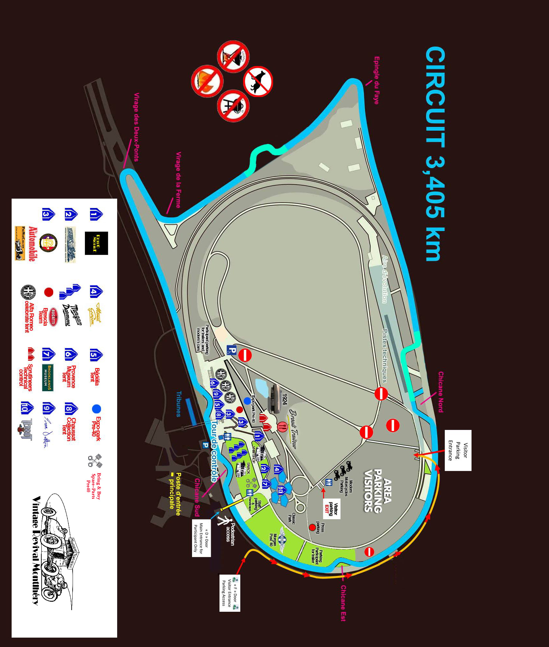

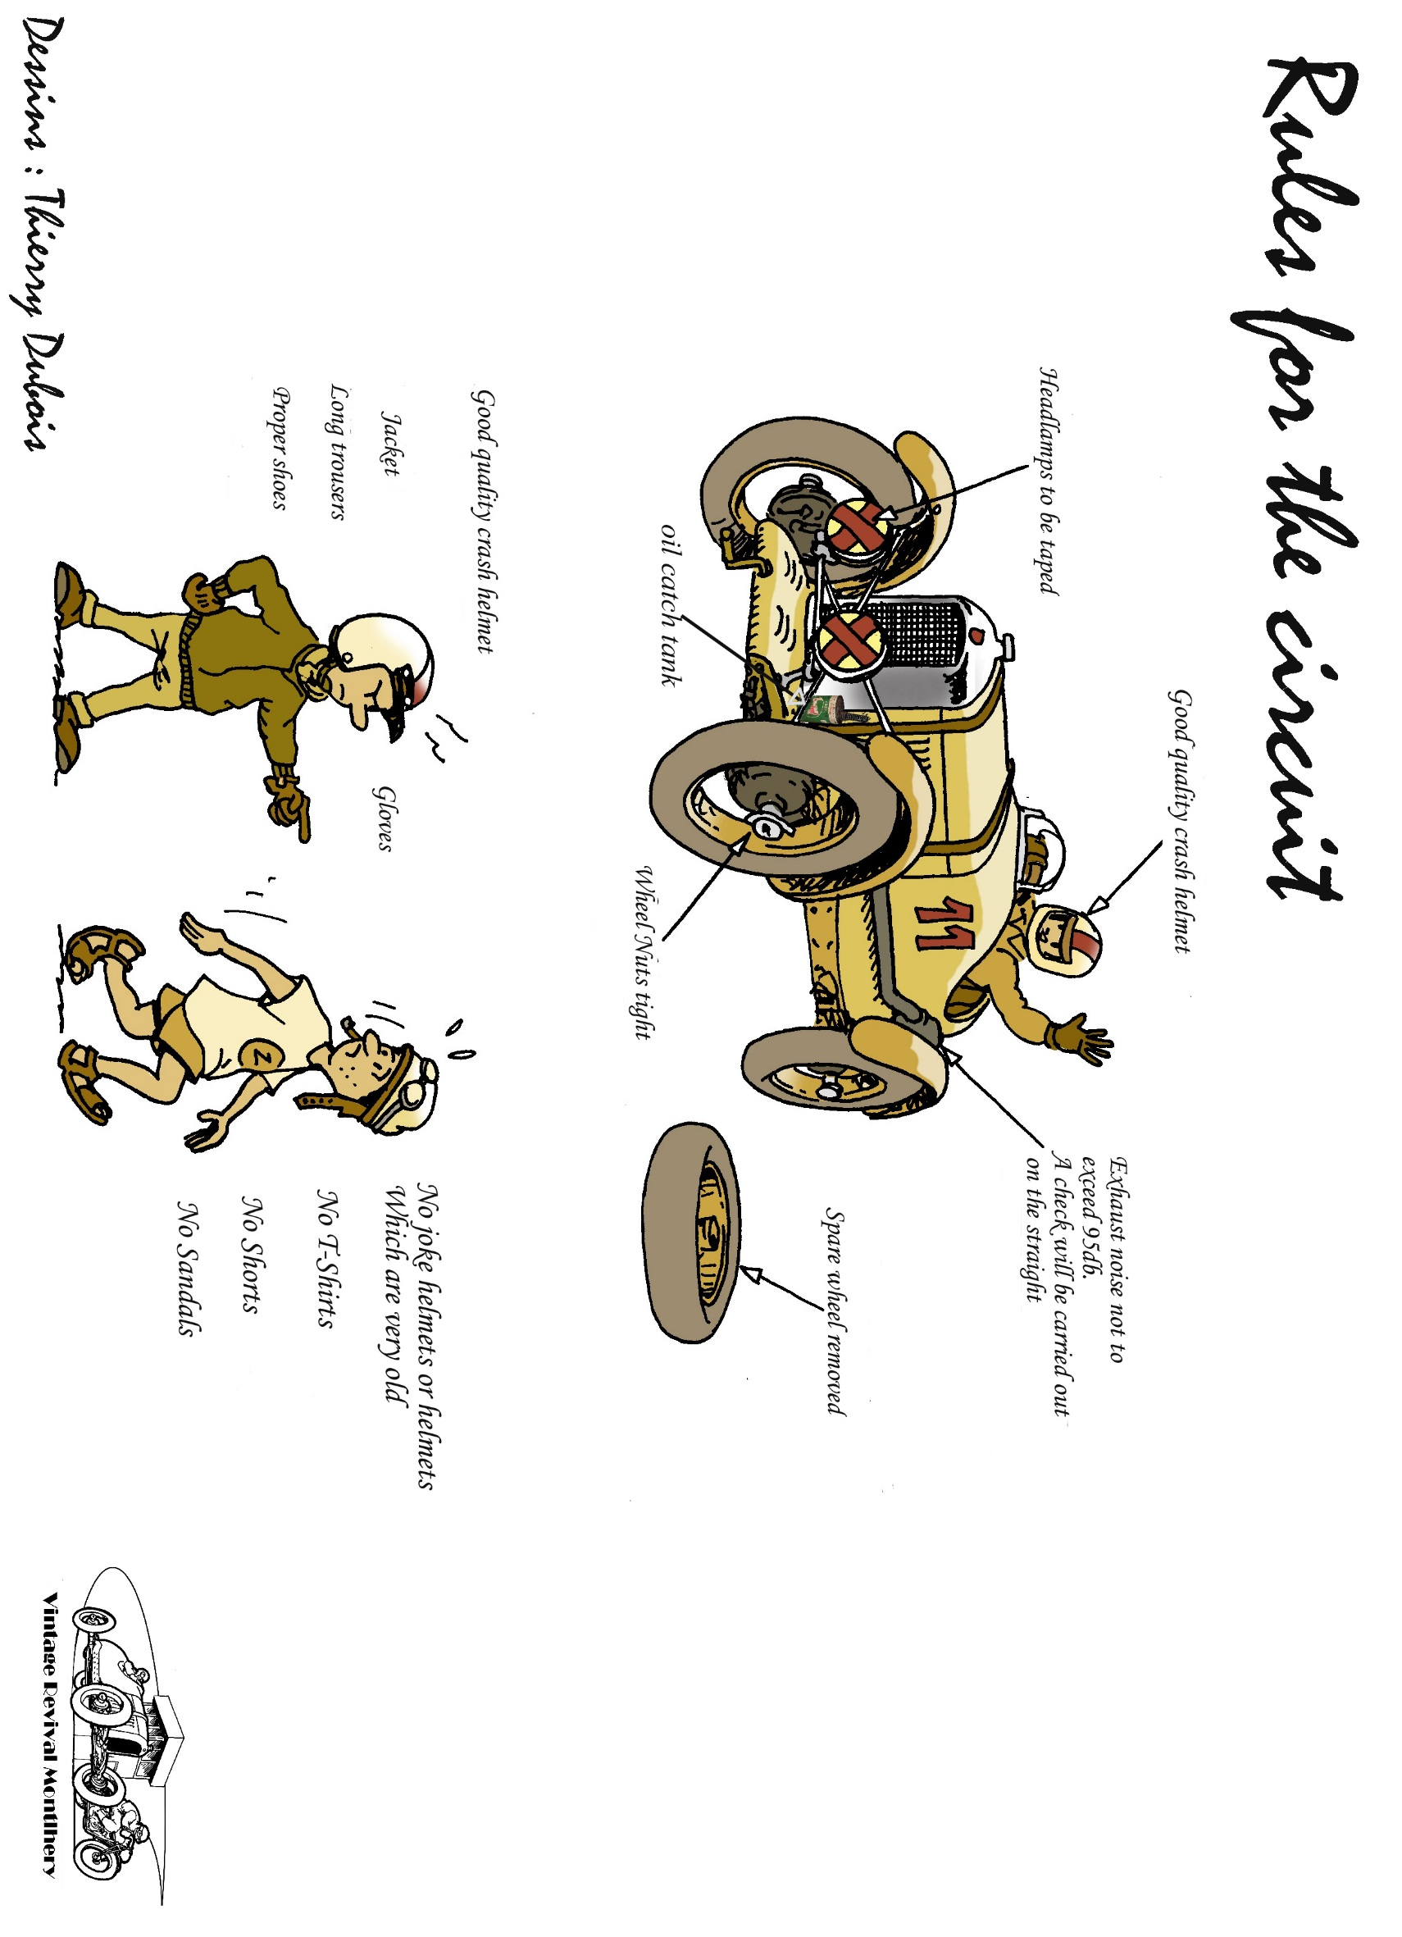



**LISTING CAMPINGS**

**Le Beau Village**

( 15 Min circuit Linas-Montlhery )

Adresse : 1, Voie des prés

91700 – Villiers sur Orge

Email: [contact@campingaparis.com](mailto:contact@campingaparis.com)

Tél : Tel: + 33 (0)1.60.16.17.86

Fax : +33 (0) 160 163 146

Web : <http://www.campingaparis.com/>

-------------------------------------------------------------------------------------------------------------

**Fontenay les Briis**

( 15 Min circuit Linas-Montlhery )

RESERVATION : Jean-Noël Bilbaut

* [jnbilbaut@neuf.fr](mailto:jnbilbaut@neuf.fr)
* 06 95 44 90 75 ou 06 83 53 29 63

Adresse : 2, Place de la Mairie

91640 Fontenay les Briis

Contact : France

Tél : +33 ( 0 ) 164 907 769

Fax : + 33 ( 0 ) 164 905 308

e-mail : [font.briis@orange.fr](mailto:font.briis@orange.fr)

Contact : Europe

Fax : + 33 ( 0 ) 164 905 308

e-mail : [font.briis@orange.fr](mailto:font.briis@orange.fr)

Information : The Camping de Fontenay les Briis is on the grounds of the château de Fontenay les Briis. Le château offers rooms to rent, the comfort is spartan but with private shower and toilet and in the style of Youth

Hostels of the seventies

