**Vintage-Revival**

|  |  |  |  |  |  |  |  |
| --- | --- | --- | --- | --- | --- | --- | --- |
| **Vintage Revival Montlhery 2019 – 11 & 12 May** |  | | |  |  |  |  |
|  |  |  |  |  |  |  |  |
| Dear Participant, | |  |  |  |  |  |  |
|  |  |  |  |  |  |  |  |
| Please find below your subscription form for Post-1940 Morgans at the Vintage Revival Montlhery 2019. | | | | | | | |
|  | | | |  |  |  |  |
| Please fill and return the completed form to us together with your choice of menus if you wish to order meals in advance. |  |  |  |  |  |  |  |
| We would be most grateful if you could advise us as soon as possible should you have to cancel for any reason. | | Copie des deux documents ci-dessous. | | | | |  |
|  |  |  | | | | | |
| Do not hesitate to contact us for any information you may require. |  |  |  |  |  |  |  |
|  |  |  | |  |  |  |  |
| *Kind regards* |  |  |  |  |  |  |  |
|  |  |  | |  |  |  |  |
| The VRM Organisation |  |  |  |  |  |  |  |
|  |  |  |  |  |  |  |  |
|  | | | | |  |  |  |
|  |  |  |  |  |  |  |  |
| Nouveau LOGO vrm 2013 | |  |  |  |  |  |  |
|  |  |  |  |  |  |  |  |

**France :**Association Vintage Revival  
28, Rue de la rotonde  
58000 NEVERS

Web : http://www.vintage-revival.fr/  
Président : Vincent Chamon - vintage-revival-montlhery@outlook.com  
Téléphone : 06 59 50 39 13  
Fax : 03 86 21 44 65

**Angleterre – UK Representant :**Jean-Frédéric Frot -jffrot@btconnect.com  
Tél : 0044 1254 824590  
Port : 0044 7746 776696

**Hollande – NL Representant :**Kees – VRM.NL@outlook.com

**Allemagne – De Representant :**Frank Seeger - [fs@anzani.de](mailto:fs@anzani.de)Tél : 0049 74312280Port : 0049 1727605798

**N°-Morg**

**Vintage-Revival**

www.vintage-revival.fr

**INSCRIPTION**

**Parc Exposition**

**REGISTRATION FORM**

**(Exposition Park)**

Circuit de Linas-Montlhéry

11 & 12 May 2019

Nom / Surname : Prénom / First name

Tél : e-mail :

###### 

Adresse / Address :

CLUB : ________________________________

Nom du président / President name : _______________________

**Espaces de stationnement Club Oui / Yes** 

***Club’s Parking spaces required***



**Clôture des**

**inscriptions**

**1er Mars  
 2019**

**Final date   
for entries**

**March 1st  
 2019**

**Barbecue, Alcool sont interdits dans l’enceinte du circuit  
 Barbecues and alcohol are forbidden inside the circuit**

**Inscriptiptions : uniquement véhicules pré 1940 ou exception ( nous consulter )  
 A Retourner à : Vintage Revival / 28, Rue de la rotonde 58000 Nevers  
( Voir Article 1 du REGLEMENT )**

[www.vintage-revival.fr](http://www.vintage-revival.fr)

[www.vintage-revival.fr](http://www.vintage-revival.fr)

**TARIFS / CHARGES**

#### Tarifs Week-end Parc Exposant – MORGAN CLUB POST 40

#### Charges for the weekend (Vintage Vehicle for the Exhibitors Park) :

***Tarif unique Véhicule CLUB MORGAN Post 40 :***

***Charge for one vehicle MORGAN-CLUB Post-40 :***

* 1véhicule – 2 personnes / One vehicle and two people : 20 € x = €

*-------------------------------------------------------------------------------------------------------------------------------------****Tarif accompagnateur / Charge for each additional person  :***

* 1 Jour 1Pers – One Day : 10 € x _____ = €

* 2 Jours 1Pers – Week-end : 15 € x = €

( Gratuit pour les moins de 16 ans / No charge for persons under 16 )

**-------------------------------------------------------------------------------------------------------------------------------------**

***Restauration au circuit / Lunch at the Track :***

**Samedi Midi / Saturday**

* LOMBARD : x 18,00€ = €

* ASCARI : x 23,00€ = €

**Dimanche Midi / Sunday noon**

* LOMBARD : x 18,00€ = €

* ASCARI : x 23,00€ = €

FRAIS PAYPAL--------------------------------------------------------------------------------- €

**REPAS VEGETARIEN POSSIBLE ( Nous consulter : vintage-revival-montlhery@outlook.com)**

***VEGETARIAN LUNCH POSSIBLE ( Please contact :* vintage-revival-montlhery@outlook.com *)***

Voir feuille suivante pour le descriptif des menus

-------------------------------------------------------------------------------------------------------------------------------------

Retour des inscriptions

(Voir Article 1 – Inscription sur le REGLEMENT)

Association Vintage Revival

28, Rue de la rotonde

58000 Nevers

www.vintage-revival.fr

**by Paypal** to our e-mail address:

vintage-revival-montlhery@outlook.com and quoting your surname and entry number in the message box**.**

**Please add €10.00 to your total to cover the commissions**

**Total** €

 **RESTAURATION** 

Vintage Revival & « Brault Traiteur » chopice of meals for Saturday & Sunday lunches:

Bookings ensure that you do not queue during the event!

A roofed spacewith tables and chairs will be available for people who have booked hot meals

**SATURDAY LUNCH**

**Lombard Menu**18,00 Euros inc

( Cold Take away meal per person )

* Ballotin of Semi Smoked Salmon, Young Leeks with Fennel cream * Roast Beef – Tomatoes Mozarella & Basil

* Brie cheese– Green salad

* Vanilla Russian Biscuit and Custard

* Bottled Mineral Water 50 c

**Ascari Menu**

23,00 Euros Prix TTC

( Hot Meal at the Cantine per person )

* Ballotin of Semi Smoked Salmon, Young Leeks with Fennel cream

* Parmentier of Duck, with vegetables in Provençale sauce

* Brie cheese – Green salad

* Vanilla Russian Biscuit and Custard

* Choice of mineral water or cola or coffee )

**SUNDAY LUNCH**

**Lombard Menu**18,00 Euros inc

( Cold Take away meal per person )

*Home-made Whiting and Scallop Mousse – cocktail sauce * Roasted Filets of Duck- Ratatouille –Green bean salad with parmesan

* Pont Lévêque cheese – Green salad

* Apricot Pie and Almonds

* 1 non alcoholic drink

**Ascari Menu**

23,00 Euros Prix TTC

( Hot Meal at the Cantine per person )

* Home-made Whiting and Scallop Mousse – cocktail sauce

*Guinea Fowl Gicolette in Cider & Apples – vegetable gratin

* Pont Lévêque Cheese – Green salad

* Apricot Pie and Almonds

* Mineral Water, Cola or Coffee

***Végétarian meals can be ordered on special request 1 month in advance***

**\* ) Snack-Buvette *“Vintage” :***

( Sandwiches, Salads, Hot Dogs, Burgers and hot and cold drinks in P1 et P7 areas)

*www.vintage-revival.fr*

PLANNING 2019

***FRIDAY 10/05/2019 – VEHICLES AND TRAILERS DROP ONLY-***

* 09:00 : Open for traders, bring and buy and spares installation only.
* 13:30 : Open to all participants to drop vehicles and trailers.

*Limited time available, please do not stay longer than necessary*

* 17:30 : Access closed to all non-UTAC personnel

**(Entrance access to the circuit closed - 17:00 - 17:05 )**

***SATURDAY 11/05/2019 - Visitors Access : 09:00 – 17:00***

* 07:30 : Open to participants
* 08:30 : Welcome by the organisers et drivers’ briefing by PAE in front of the MOTUL Truck
* 09:00 – 09:15  / Grid A ( 35 véhicles )
* 09:20 – 09:35  / Grid B ( 35 véhicles )
* 09:40 – 09:55 / Grid C ( 35 véhicles )
* 10:00 – 10:15 / GP Bikes Grid ( 47 véhicles )
* 10:20 – 10:35 / Grid D – Flying Banana - ( 35 véhicles ) (Three wheelers )
* 10:40 – 10:55 / Grid E - Grand-Prix Cars ( 35 véhicles )
* 11:00 – 11:15 / Race Bikes Grid ( 47 véhicles )
* 11:20 – 11:35 / Grid F ( 35 véhicles )
* 11:40 – 11:55  / Grid G ( 35 véhicles ) ( Racer & Special )



 

* 12:00 – 12:15 / Grid H « YCAR » ( 35 véhicles )
* 12:20 – 12:35 / Grid « Jean Lalan » Pre-1919 Bikes & Exception vehicles
* 12:40 – 12:55 / Grid Board Track & Records Bikes

12h55 : Lunch Break (No Alcohol )

* 14:30 – 14:45 / Grid A ( 35 Véhicles )
* 14:50 – 15:05 / Grid B ( 35 Véhicles )
* 15:10 – 15:25 / Grid C ( 35 Véhicles )
* 15:30 – 15:45 / GP Bikes Grid ( 47 véhicles )
* 15:55 – 16:05 / Grid D – Flying Banana - ( 35 véhicles ) (Three wheelers )
* 16:10 – 16:25 / Grid E – Grand Prix Cars ( 35 Véhicles )
* 16:30 – 16:45 / Race Bikes Grid ( 47 véhicles )
* 16:50 – 17:05 / *Track open to all bicycles pre 1940* Grid F ( 35 véhicles )
* 17:10 – 17:25 / Grid G ( 35 véhicles ) ( Racer & Special )
* 17:30 – 17:45 / Grid H « YCAR » ( 35 véhicles )
* 17:50 – 18:05 / Grid « Jean Lalan » Pre-1919 Bikes & Exception vehicles
* 18:10 – 18:25 / Grid Board Track & Record

18:25 : Circuit runs end for the day

19:30 : Gates closed

Planning 2019

***SUNDAY 12/05/2019 - Visitors Access : 09:00 - 17:00***

* 08:00 am : Open to participants
* 09:00 – 09:15  / Grid A ( 35 véhicles )
* 09:20 – 09:35  / Grid B ( 35 véhicles )
* 09:40 – 09:55 / Grid C ( 35 véhicles )
* 10:00 – 10:15 / GP Bikes Grid ( 47 véhicles )
* 10:20 – 10:35 / Grid D – Flying Banana - ( 35 véhicles ) (Three wheelers )
* 10:40 – 10:55 / Grid E - Grand-Prix Cars ( 35 véhicles )
* 11:00 – 11:15 / Race Bikes Grid ( 47 véhicles )
* 11:20 – 11:35 / Grid F ( 35 véhicles )
* 11:40 – 11:55  / Grid G ( 35 véhicles ) ( Racer & Special )



 

* 12:00 – 12:15 / Grid H « YCAR » ( 35 véhicles )
* 12:20 – 12:35 / Grid « Jean Lalan » Pre-1919 Bikes & Exception vehicles
* 12:40 – 12:55 / Grid Board Track & Records Bikes

12h55 : Lunch Break (No Alcohol )

*Track open to all bicycles pre 1940*



*13 : 30 – VRM Award by*

* 14:30 – 14:45 / Grid A ( 35 Véhicles )
* 14:50 – 15:05 / Grid B ( 35 Véhicles )
* 15:10 – 15:25 / Grid C ( 35 Véhicles )
* 15:30 – 15:45 / GP Bikes Grid ( 47 véhicles )
* 15:55 – 16:05 / Grid D – Flying Banana - ( 35 véhicles ) (Three wheelers )
* 16:10 – 16:25 / Grid E – Grand Prix Cars ( 35 Véhicles )
* 16:30 – 16:45 / Race Bikes Grid ( 47 véhicles )
* 16:50 – 17:05 / Grid F ( 35 véhicles )
* 17:10 – 17:25 / Grid G ( 35 véhicles ) ( Racer & Special )
* 17:30 – 17:45 / Grid H « YCAR » ( 35 véhicles )
* 17:50 – 18:05 / Grid « Jean Lalan » Pre-1919 Bikes & Exception vehicles
* 18:10 / Final parade with participation of the static display Park vehicles

19h30 : Gates closed

END OF THE EVENT

|  |
| --- |
|  |

www.vintage-revival.fr

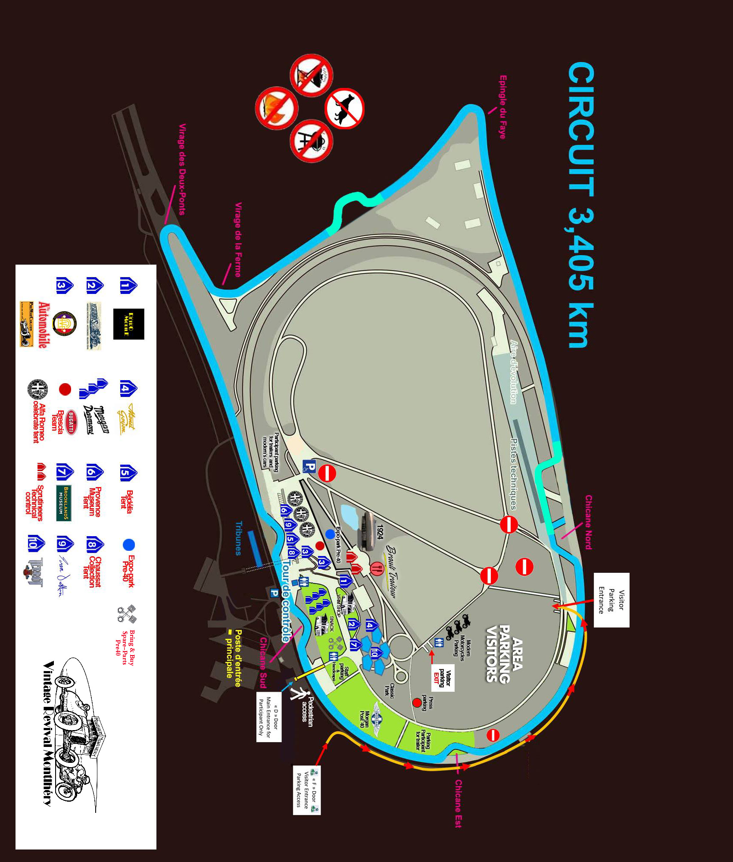



**LISTING CAMPINGS**

**Le Beau Village**

( 15 Min circuit Linas-Montlhery )

Adresse : 1, Voie des prés

91700 – Villiers sur Orge

Contact : France - Europe

Tél : +33 ( 0 ) 160 161 786

Fax : +33 ( 0 ) 160 163 146

Web : <http://www.beau-village.com>

-------------------------------------------------------------------------------------------------------------

**Fontenay les Briis**

( 15 Min circuit Linas-Montlhery )

Adresse : 2, Place de la Mairie

91640 Fontenay les Briis

**Contact : France**

Tél : +33 ( 0 ) 164 907 769

Fax : + 33 ( 0 ) 164 905 308

e-mail : [font.briis@orange.fr](mailto:font.briis@orange.fr)

**Contact : Europe**

Fax : + 33 ( 0 ) 164 905 308

e-mail : [font.briis@orange.fr](mailto:font.briis@orange.fr)

Information : The Camping de Fontenay les Briis is on the grounds of the château de Fontenay les Briis.

The château offers rooms to rent, the comfort is spartan but with private shower and toilet and in the style of Youth Hostels of the seventies

